Module 2: Critical Thinking Assignment

Nathan Rogers
Colorado State University Global
Course Code: CSC505
Dr. Luis Gonzalez
02/23/2025

Assignment
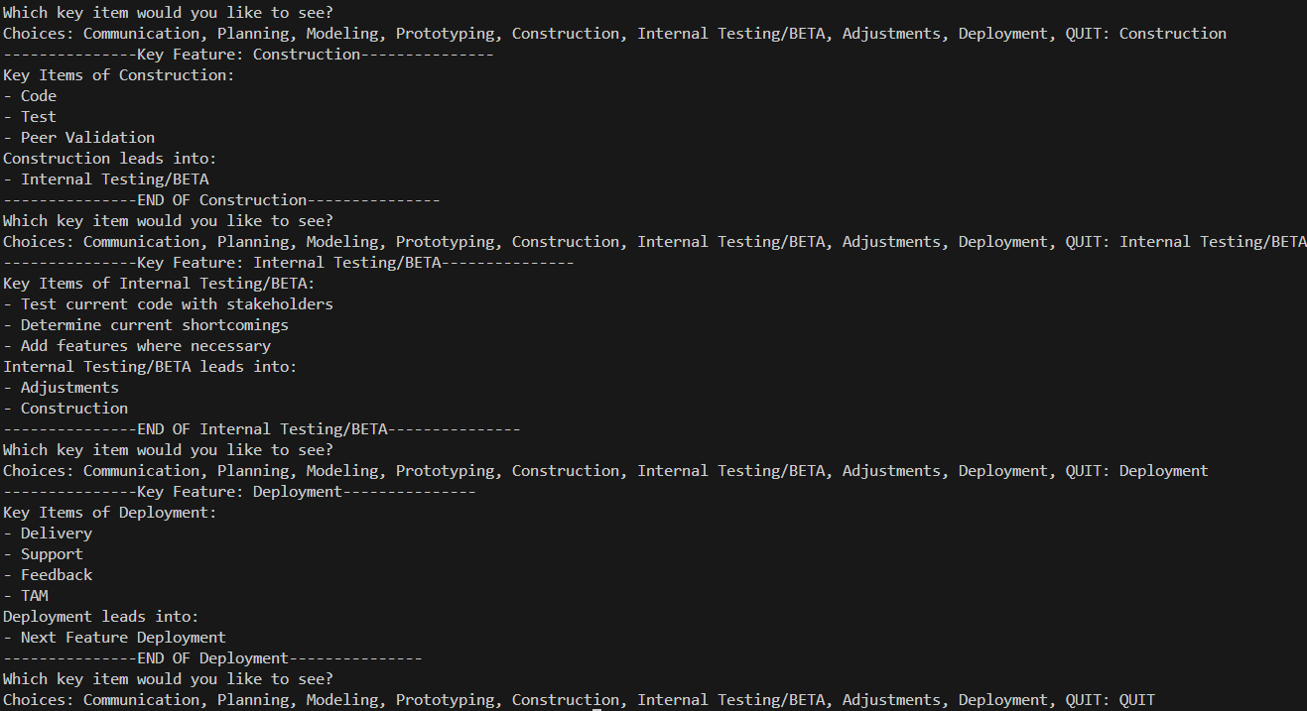
Implement the Rogers_Model class using Python, which will prompt the user to input the key elements of the diagram and return these objects in a well-formatted output. Below are the outputs from a select few choices to demonstrate the output you would get as a user:

Based on this modified waterfall diagram (Red lines indicate changes to the original waterfall diagram):
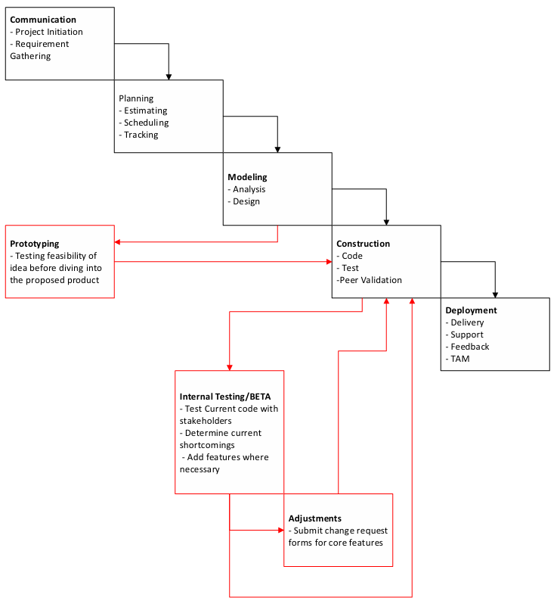
References
Pressman, R. S., & Maxim, B. R. (2020). Software engineering: A practitioner’s approach. McGraw-Hill Education.
Whitson, G. M. (2022). Software Engineering. Salem Press Encyclopedia of Science.
Lishner, I. (2023). Enhancing Strategic Planning of Projects: Selecting the Right Product Development Methodology. MDPI, 14(12), 632–654.

